The Spiritual Formation Team Invites You to
A Workshop on Blessings: Unconditional Gifts of Grace
Presenter: Rev. Pamela Short
10:00 a.m. to 3:30 p.m.
Cost $25.00 includes lunch
Registration online at www.maumeevp.org

Choose from one of 3 dates and locations:
Tuesday, April 28, 2020 First Pres. Blissfield, Michigan
Wednesday, August 19 First Pres. Fostoria, Ohio
Thursday, October 29, 2020 First Pres. Defiance, Ohio

Who might benefit from this workshop:
Pastors, elders, worship leaders, grandparents, parents, aunts, uncles, friends and enemies!

Workshop Description
In a world where words are continually used to diminish dignity, we have a God who speaks and life rises up. Together we will explore our potential to bless others with the gifts God has waiting for our world. We will look at both personal opportunities to bless and community opportunities as found in worship settings.

Participants and presenter together will
Examine how speech is a central act of God’s work in the world
Relate blessing to our participation in the Mission of God
Tell stories of blessing
Connect Scripture and needs of the world in our words of blessing
Distinguish a benediction from a charge or an instruction
Prepare written blessings
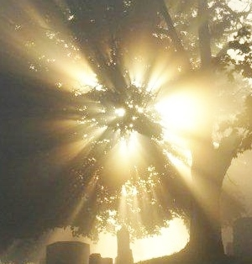

“And God said, ‘Let there be light.’ And there was light.
And God saw that the light was good.”
Genesis 1:3-4

