Policy on Dismantling Racism Training
__________ Presbyterian Church of ____________

The _______ Presbyterian Church of _______ rejects any form of racism, discrimination, or prejudice. We recommit ourselves to creating a culture of belonging in which every person, created in the image of God, feels welcomed, valued, respected, and heard. We further believe that diversity, equity, and inclusion enhance the health of the Body of Christ, maintaining a standard of excellence in all aspects of our life together. To that end:

- Our Session will provide the resources provided by the Presbytery and/or Synod and publicize educational opportunities that focus on dismantling racism within our church institutions (Presbytery and congregations) and the communities we serve. These materials will be shared with all elected leaders and staff of the church, and training will be made available to any elected leader who desires to engage in such training.

- The Dismantling Racism training is required at least once every three (3) years for:

• The Moderator of the Session

• Any other pastoral leader who is engaged in ministry in the church (e.g. Associate Pastors, Commissioned Ruling Elders (CREs), Parish Associates, etc.).

• All program staff is required to attend within one year of hire/election.

- The church strongly encourages Dismantling Racism training at least once every three (3) years and within one year of hire/election for:

• Any Ruling Elder or Deacon serving a term in leadership

• All staff of the church

• Any others who have a heart for dismantling racism

- Training Administration & Oversight

This policy will be administered by the __________ Committee/Team. The Clerk is responsible for recording in the minutes any in the church who have completed training, and for those for whom training is required ensuring notation of participation in their permanent files and notifying them of compliance deadlines.

The Moderator of Session will serve as staff support to the Team.

- Provision for Training Evaluation & Policy Review

The ________ Committee/Team shall also undertake an initial review of this policy by the end of 20__.

Funding
The Session shall designate funding to help ensure that required participants can attend at minimal expense to the individual or congregation.

Scriptural and Theological Framework for Anti-Racism Training

As followers of Christ, we are called to love our neighbor as ourselves (Matthew 22:39) and to fully embrace the fact that all people are equally loved by God (John 3:16, Romans 5:8) and equally valued by God (Galatians 3:28).

These New Testament passages rest on the foundation of the Old Testament. From the Pentateuch’s outline of a covenant community built on pillars of justice and mutual responsibility to the prophets’ fiery presentations of God’s expectations and calls for fairness that echo through the Wisdom literature, the Old Testament reminds us again and again about God’s call to full inclusion and equity.

The creation story portrays God’s creation of humankind in one image, without race, that of the Lord. The Mosaic law makes clear that to love neighbor is to love the Lord. When God’s people err, we hear the thunderous correction of the prophets speaking for God.

Amos 5:21-24: ²¹ “I hate, I despise your religious festivals; your assemblies are a stench to me. ²² Even though you bring me burnt offerings and grain offerings, I will not accept them. Though you bring choice fellowship offerings, I will have no regard for them. ²³ Away with the noise of your songs! I will not listen to the music of your harps. ²⁴ But let justice roll on like a river, righteousness like a never-failing stream!

Isaiah 40:4: Every valley shall be lifted up, and every mountain and hill be made low; the uneven ground shall become level, and the rough places a plain.

Micah 6:8: He has told you, O mortal, what is good, and what does the Lord require of you but to do justice and to love kindness and to walk humbly with your God?

From cover to cover, scripture portrays God’s vision of equality, equity, fairness, and justice. To fully live into this vision and love our neighbor as ourselves, and given the current racial climate of our nation and world, we must seek to know and understand the effects of racism on our neighbors of color. Understanding the sin of racism and its traumatic effect on those who experience it, is of paramount importance if divisive racial barriers and systems are to be torn down. We are called to create and sustain a culture of racial reconciliation and accountability to the communities the presbytery serves, becoming fully the Beloved Community God intends for us, following the Great Ends of the Church to promote social righteousness and exhibit the kin-dom of heaven to the world.
Curriculum: “What LIES Between Us”

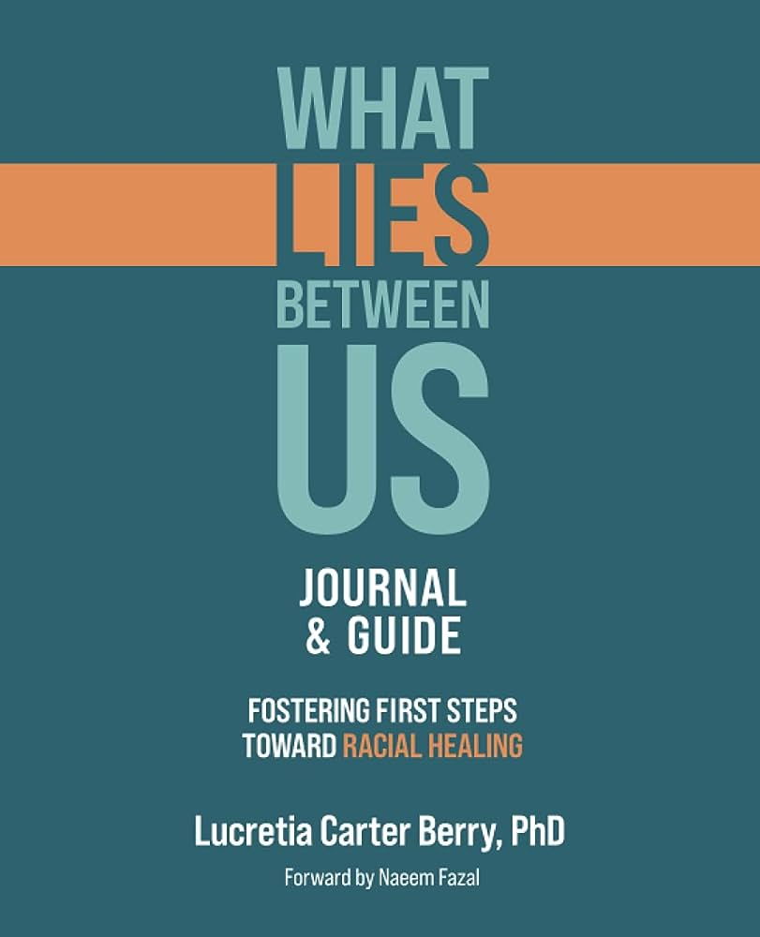
A 5-Week Self-paced Anti-racism Educational Course from brownicity.com

About The Course: Anti-race/ism Curriculum Specialist, Dr. Lucretia Berry and Team Brownicity designed the What LIES Between Us series to guide, support, and equip ‘new comers’ with an analytical framework for examining race and racism in the United States.

Learners will be equipped with a historical, political, and social context for understanding race/ism and how it is sustained. The content will allow participants to build a sound knowledge base and develop a perspective beyond popular discourse and uninformed opinions. With a practical understanding of contributing ideologies–like white supremacy, meritocracy, colorblindness–and interpersonal and systemic dynamics—like unconscious bias, and power and privilege – participants will have a broadened awareness of themselves, “others,” and our interconnected society.

