

Quiet Days at Lake Diane

Monday, July 15, 2024

Thursday, August 15, 2024

Lake Diane, 2031 Sampson Rd., Camden, Michigan

Choose either day and register by text or email:

Pamela Short 419-403-0049

[pamelashort2002@gmail.com](mailto:pamelashort2002@gmail.com)

Please include dietary restrictions

What to expect on a Quiet Day:

A day without cell phones or computers.

Cell phones left in car.

No calls or texts made or received during quiet hours.

Worried about emergencies? Offer your family these numbers: 517-234-2772 & 419-403-0049

Brief devotional at 9:30 a.m.

Communion at 2:00 p.m.

Conversations limited to between you and God.

Breakfast and Lunch will be provided and eaten on your own time-table.

Available at the cottage:

Books

Art supplies

Kayaks & life jackets

Floating devices for relaxing in the water

Towels

Fishing poles

Sand toys

Garden tools

Chairs

Blankets

**Available nearby:**

Walking paths

Farm stand with veggies

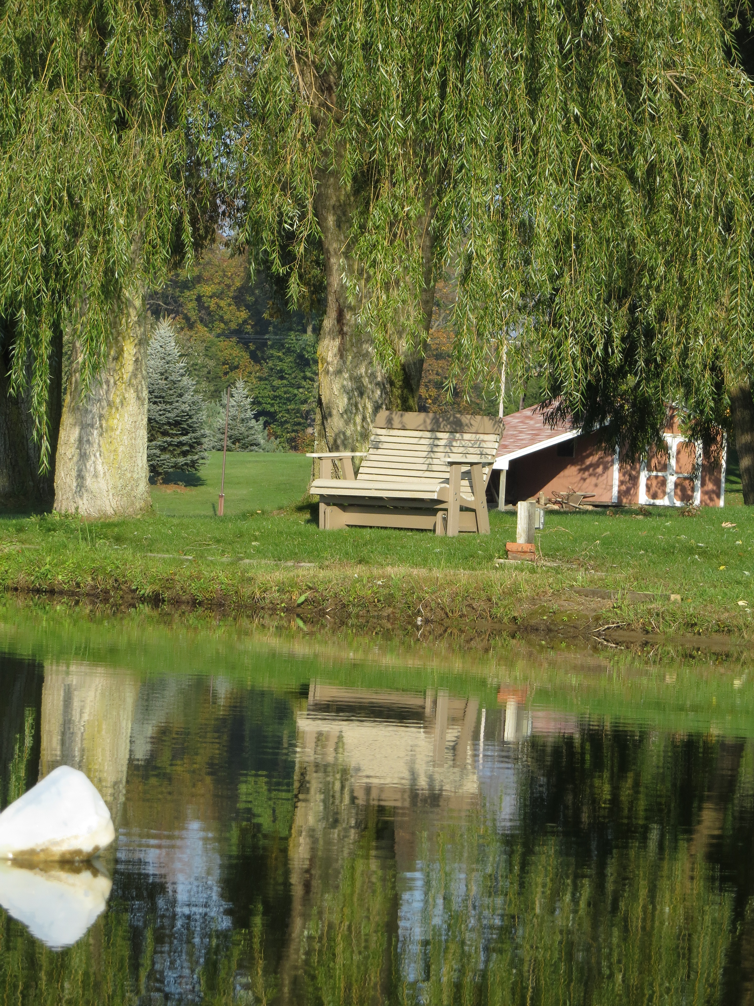

***“Then they were glad because they had quiet.”***

***Psalm 130:7a***