Maumee Valley Presbytery Invites you to our
Fall Spiritual Formation Retreat
October 13, 14, & 15, 2024
“The Imprint of Christ”

Artist Joyce Nafziger along with Pamela Short will lead us in reflecting on the marks Jesus makes on our lives. Nature walks will be followed by very simple print making. You may go away with a modest bookmark or
a stunning bulletin cover.

If art is not your thing, come anyway and take in the mystery of God’s creations at Lial. The grounds are particularly beautiful in the fall. Woods and meadows, little lakes and large hospitality provide opportunities for rest and reflection.

Location:
Lial Renewal Center, 5908 Davis Road Whitehouse, Ohio
www.lialrenewalcenter.org

Arrive Sunday
Any time after 3:00 p.m.
A lite supper will be available at 5:30 with devotional time beginning at 7:00 p.m.

Depart Tuesday
at noon

Ms. Joyce Nafziger is a retired teacher who believes that every student has a spark of creativity ready to be captured. From kindergarteners to high schoolers and beyond, Joyce has offered patient and encouraging words as she led her students with clear instruction. Her life is marked by the gentle strength of the Holy Spirit.

Rev. Pamela Short is a retired pastor who serves on the MVP Spiritual Formation Team. She carries the message of God’s love to various churches in the Presbytery through pulpit supply. “God’s call on my life includes a particular emphasis on blessing others. It is my hope that through this retreat your heart and eyes will see anew the imprint of Jesus’ blessings on your life.”

BASIC RETREAT
$25 per person for

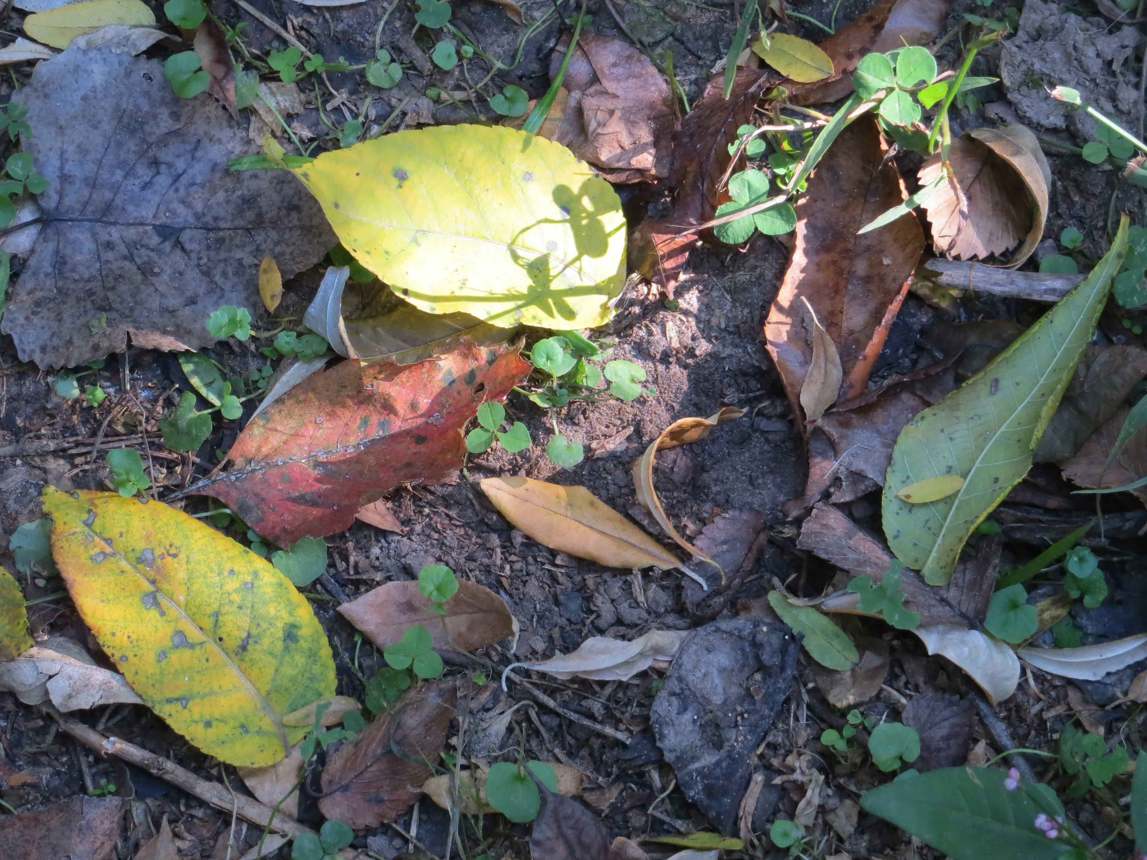
all sessions and meals
OVERNIGHT LODGING
$35 per person/per night
with a shared bathroom on the hall
$40 per person/per night
with a private bath
Don’t let the cost stop you!
Scholarships available!
Email matt@maumeevp.orgMEEVP.ORG
REGISTRATION:
www.maumeevp.org

